1. **Environment:**

The n * n board with m consecutive pieces to win

1. **Search Space:**

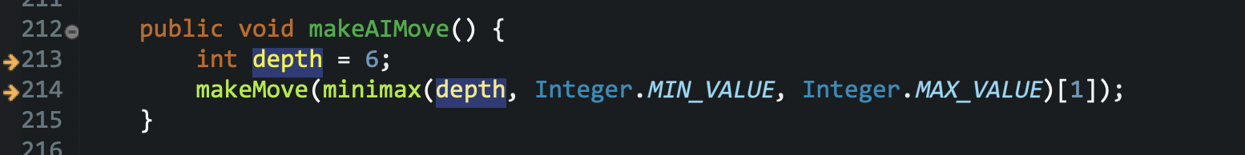

We set a variable called depth in the algorithm. When the AI is thinking, it will search all the space distributed in all the depth of the tree.

1. **Evaluation function:**

Heuristic Function: When there is one more chess piece in a line on the board, the point will multiple 10. This rule can be applied to the opponent side. The total score of each side equals total of the points. And the final score equals the total score of Human minus the total score of AI.

1. **Two agents:**

AI & Human

1. **Work Distribution:**

Group Member: Jie He, Haoqiang Lyu, Yang Wu, Yuhao Yang

Jie He: The heuristic function

Yuhao Yang: Implement the Board class except the heuristic function

Haoqiang Lyu: The document, test, add some prompts.

Yang Wu:

1. **Code Address:**

https://github.com/JieHe96/CSCI6511_Project2

1. **Example:**

**（1）**

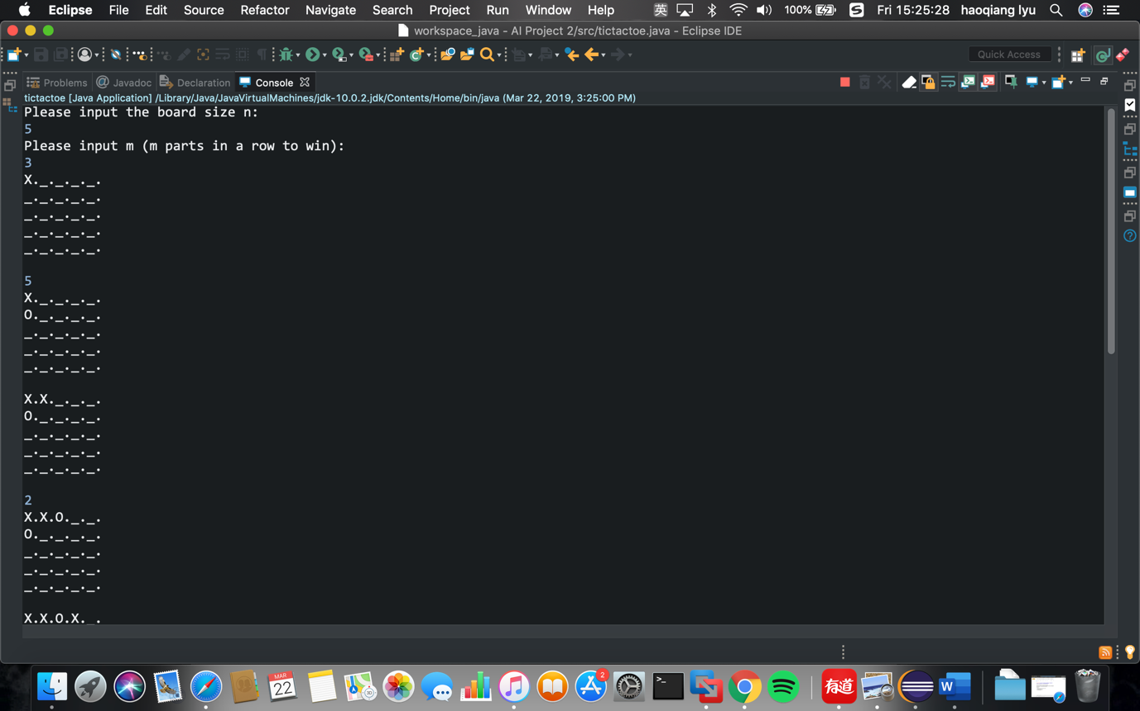

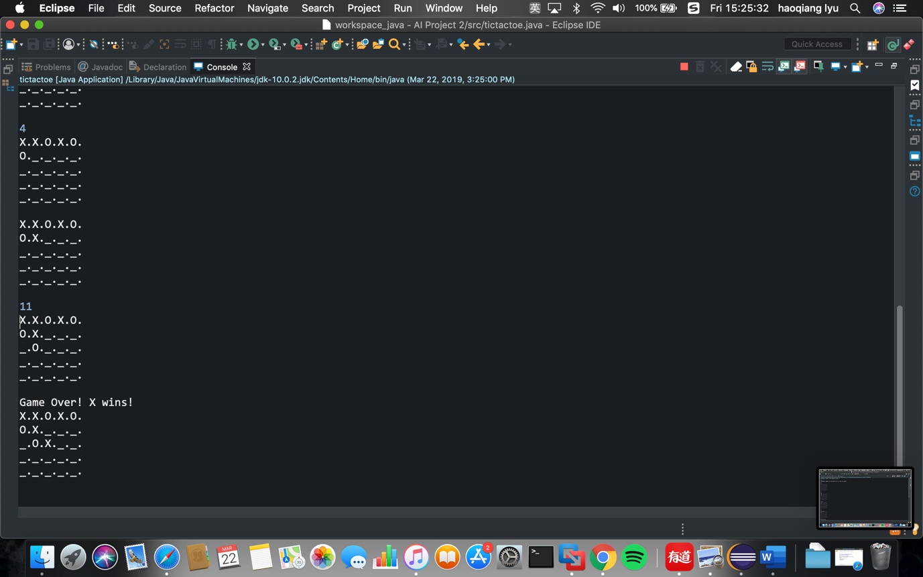

**（2）**

